Assignment - 12
Task -1
Description: Linear Search implementation
Task: Write python code for linear_search () function to search a value in a list and extract its index.
Prompt: "Write a Python program that implements a linear_search() function. The program should take a list and a value from the user, search for the value using linear search, and print the index if found
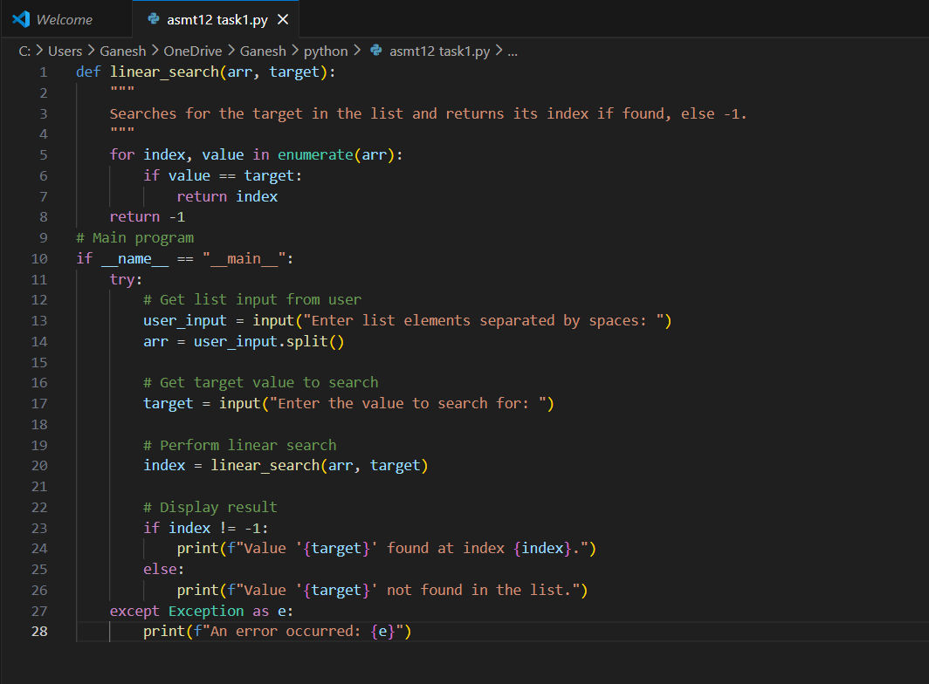

Practical Out:

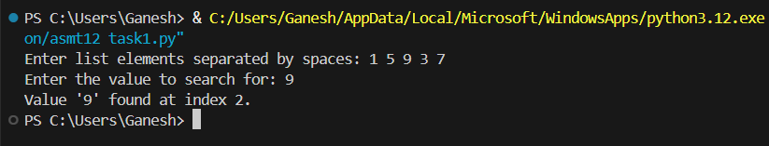

Task - 2
Description: Sorting Algorithms
Task: Ask AI to implement Bubble Sort and check sorted output
Prompt: "Write a Python program that implements Bubble Sort. The program should take a list as user input, sort it using Bubble Sort, and then print the sorted output."

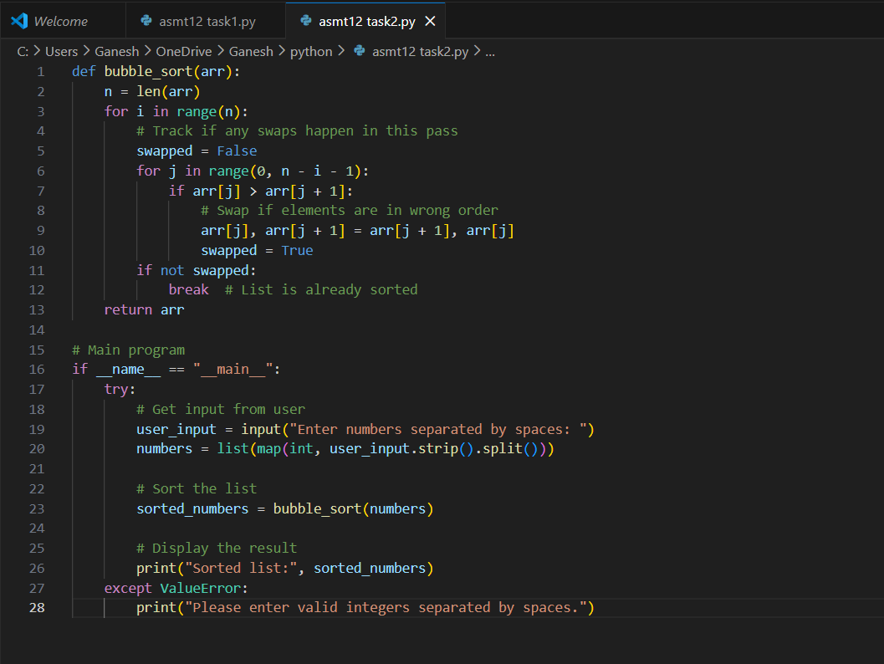

Practical Output:

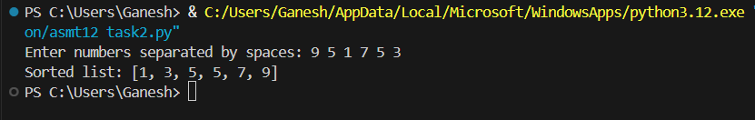

Task - 3
Description: Optimization
Task: Write python code to solve below case study using linear optimization.

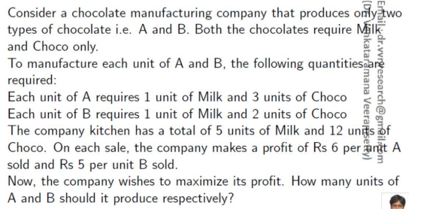

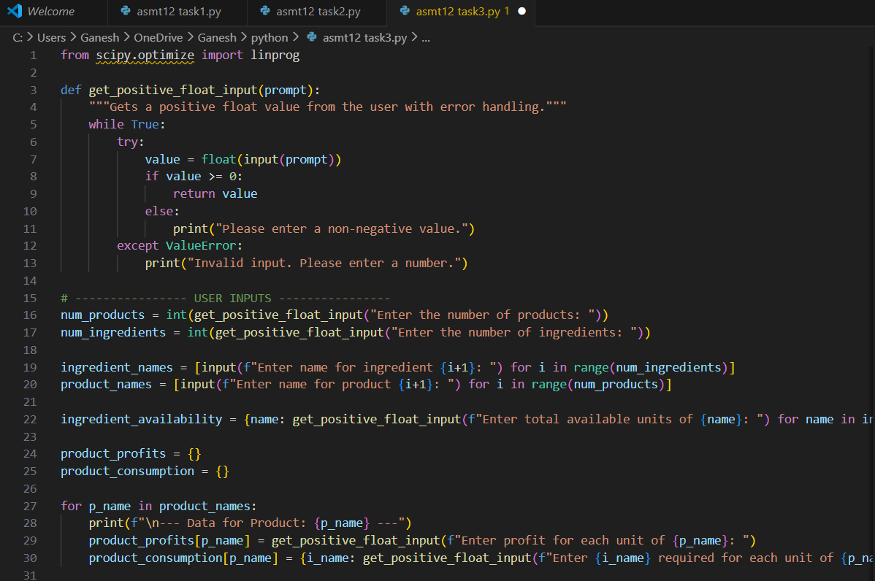
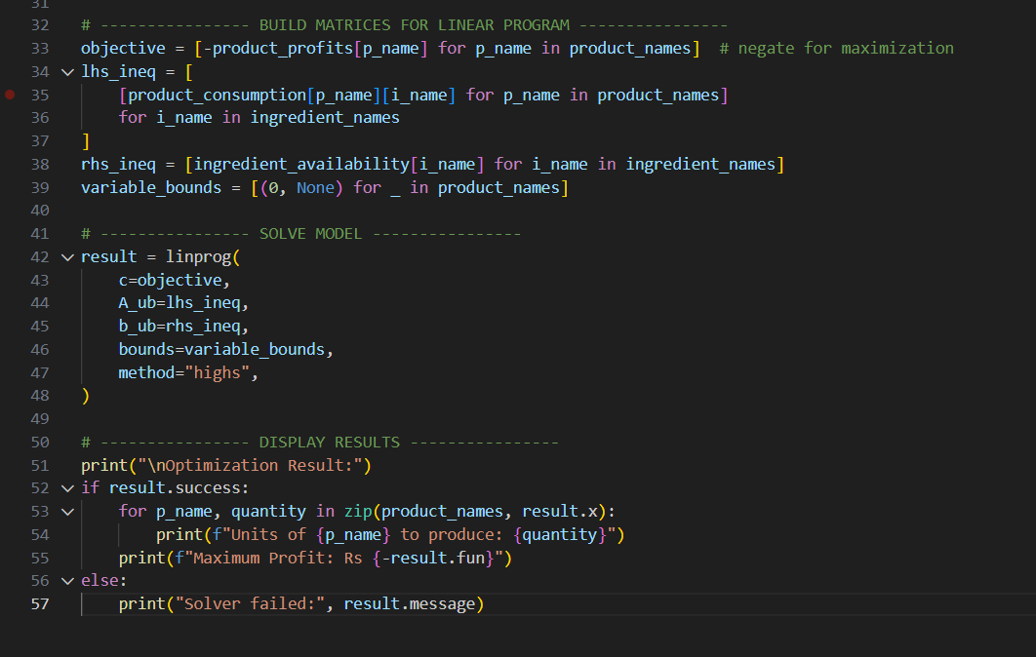

Practical Output:

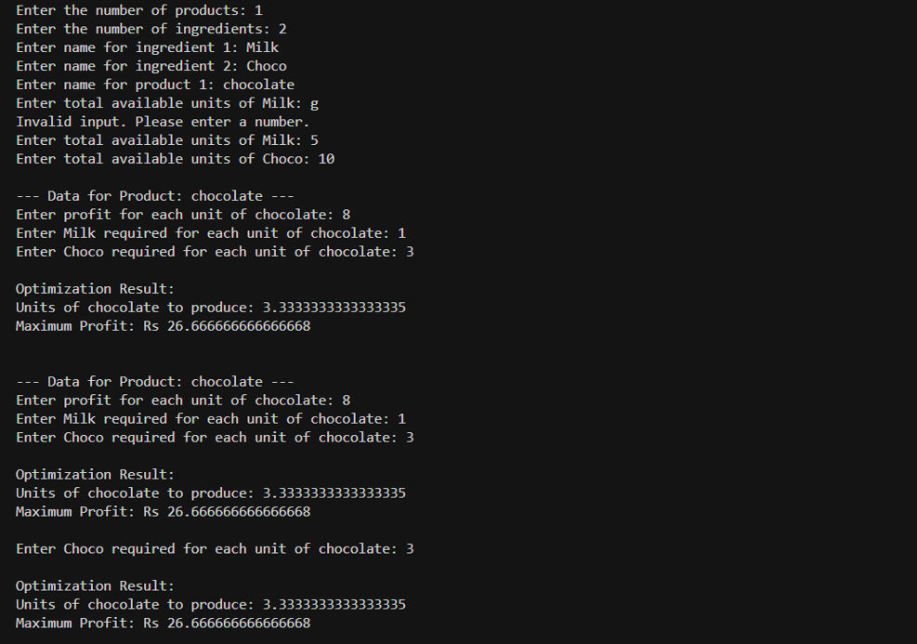
Task – 4
Description: Gradient Descent Optimization
Task: Write python code to find value of x at which the function f(x)=2X3+4x+5 will be minimum
Prompt: "Write Python code to compute the derivative of f(x)=2x³+4x+5, find the critical point, and print the value of x where the function is minimum."

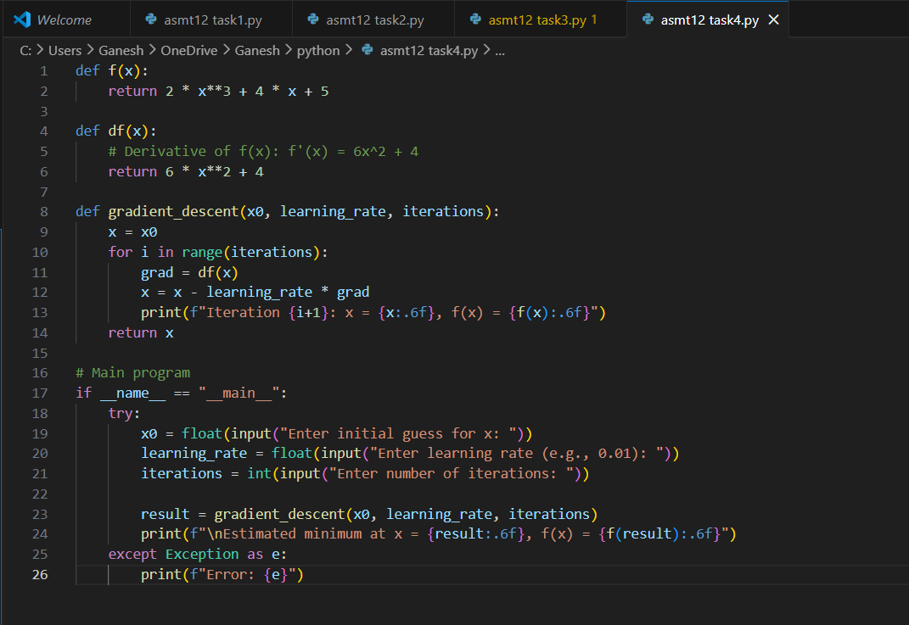

Practical Output:

